UNIVERSITY OF MEDICINE, TIRANA

Internationalization strategy
2020 - 2024

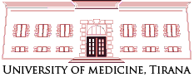

Content

Legal Basis
Information about University of Medicine, Tirana
History of UMT
Mission
Vision
Aim
Internationalization of UMT
International relations
Relevance of strategy
European Projects
Strategic priorities

Legal Basis

- Law 80/2015 on Higher Education and Scientific Research in Higher Education Institutions in the Republic of Albania
- National Education Strategy 2021-2026
- Statute of University of Medicine, Tirana
- Regulations of University of Medicine, Tirana
- The strategic plan of University of Medicine, Tirana

Information about University of Medicine, Tirana (UMT)
• The UMT is a public Higher Education Institution in full compliance with the criteria of Bologna system.
• The UMT offers study programs in three academic levels:
- Bachelor
- Master of Sciences/Professional - Integrated Master of Sciences
- Doctoral Studies
History of UMT
- Higher Medical Institute since 1952.
- On 1957 was joint to University of Tirana as Faculty of Medicine.
- University of Medicine, Tirana (UMT) was created in 2013, as a continuity of Faculty of Medicine, separating from University of Tirana.

- The UMT has three faculties:
- Faculty of Medicine
- Faculty of Dental Medicine
- Faculty of Technical Medical Sciences

Mission
- The University of Medicine, Tirana is a public higher education institution of medical sciences in the Republic of Albania, which:

  - Prepares and educates health professionals based on three study cycles, in line with the highest professional standards;
  - Applies and stimulates scientific research;
  - Inspires and promotes innovation in the medical sciences field;
  - Educates and inspires the future leaders in the field of medicine.

- The University, in cooperation with students, government, health services and civil society, transmits knowledge and prepares health professionals that practice optimal care to patients, with the aim of preventing and treating diseases, as well as advancing scientific research to the benefit of health.
Vision
UMT is the most important academic and research center of national medical sciences and aims at maintaining this position. This key and guiding role in education, scientific research and health care will be performed through reformation and modernization of the institution, transforming it into an academic, scientific research and medical institution that:
- Inspires and promotes university and cross-university cooperation approaches;
- Supports the academic staff and students;
- Recognizes, supports and promotes excellence;
- Understands, follows up and supports the society’s needs;
- Provides orientation and models to be followed;
- Educates, appreciates, creates and maintains leadership, relying on best traditional and future values;
- Cultivates excellence and collegiality within an inclusive community.
Aim
The University of Medicine, Tirana, as the only public institution of medical sciences aims to maintain its guiding role in coping with future challenges of health care, while aiming at preparing future health professionals, orientated towards:
- Health care based on facts;

- Assessment of health care quality and performance;
- Transition from hospital medical care to ambulatory medical care and home-based medical care;
- Integrated proactive and preventive medicine;
- Health care provision by professional multidisciplinary and interdisciplinary teams;
- An ethical partnership between health professionals and patients
Internationalization strategy of UMT
- For the University of Medicine, Tirana the internationalization strategy is an integral part of the university development strategy. Our internationalization strategy focuses on building partnerships in education, innovation and research.
- Actually, the UMT has implemented various Credit Mobility Projects in the framework of Erasmus+ Program with various Universities in Europe such as in Italy, Turkey, Romania, Germany, Hungary, Austria, Spain, Greece, Poland, Estonia and Slovenia.

UMT is member of UNIADRION, BUA, AUF.
- During last years, UMT has signed about 100 Memorandum of Understanding (MoU) with other Higher Education Institutions (HEI), and promotion of cooperation with them in the academic, scientific research and medical field.
- We aim to expand for the following years our relationship with European countries, giving our students and staff the possibility of teaching and training to gain more experience. The participation in some International projects last years has helped us to increase our international footprint and provided our students and Faculties with exposure to European education system.

- The University of Medicine, Tirana (UMT) makes all efforts to increase in a higher level the collaboration with EU countries in order:

- To improve the quality of higher education;
- To develop new and innovative education programs;
- To modernize higher education systems through a systematic collaboration with different regions of the world through joint initiatives.
- To share the best practices, improving the forms and methods of organizing the teaching process, introducing the latest technologies in the teaching process.
- To conduct the joint analysis of materials (scientific, methodological, textbooks, educational aids, courses, lectures, etc.) in written and electronic form.
- To exchange publications and new scientific literature between libraries.
- To invite lecturers from qualified faculties for holding lectures related to various fields of science, organizing joint seminars for improving the qualification of the personnel.
- To organize student exchange between two institutions.

Relevance of strategy
- Increasing opportunities for mobility for UMT students and staff.
- International promotion and recognition of research carried out by UMT staff.
- Demonstrating the international dimension of activities in research, development and transfer of knowledge and technologies carried out at UMT.
- Deepening international cooperation through links with the Albanian Diaspora.
- Greater participation in scientific activities and research and development projects.
- Building institutional capacities for international projects.
Recently, UMT has signed the Memorandum of Understanding with University of Bologna, University of Budapest Semmelweis, University La Sapienza, Rome, University of Chieti-Pescara about Erasmus+ Mobilities, Capacity Building Projects, Joint Programs and Doctoral Studies.
European Projects
- MEDIGENE - Genetic and environmental factors of insulin resistance syndrome and its long-term complications in immigrant Mediterranean populations (FP7)
- EUSCREEN – Implementation of cost-optimized childhood vision and hearing screening program in middle-income countries in Europe (Horizon 2020)
- DigiCare4You - An intersectoral innovative solution involving DIGItal tools, empowering families and integrating community CARE services for the prevention and management of type 2 diabetes and hypertension (Horizon 2020)
- PIECES - Towards large-scale adaption and tailored implementation of evidence-based primary cancer prevention program in Europe and beyond (Horizon-RIA)
- EARLY - Evaluating, Identifying and Reducing determinants MHC in Youth (Horizon HLTH)

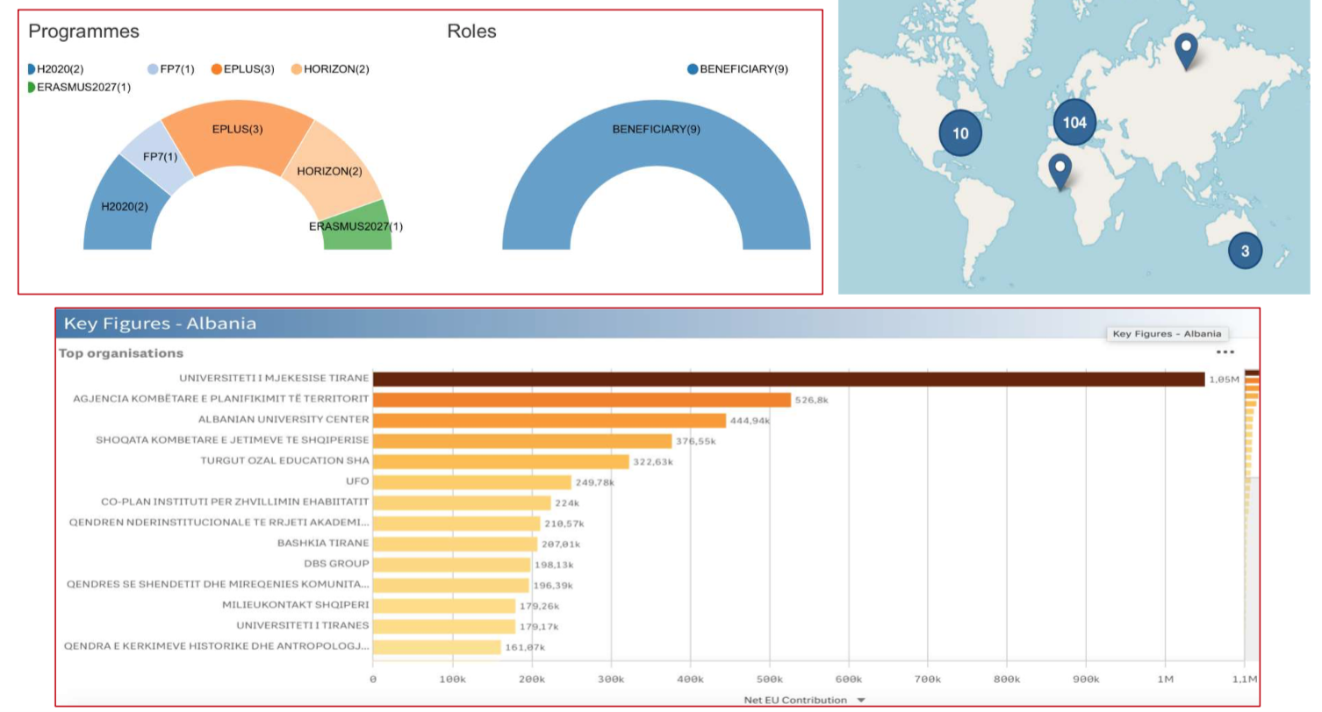

Projects CBHE
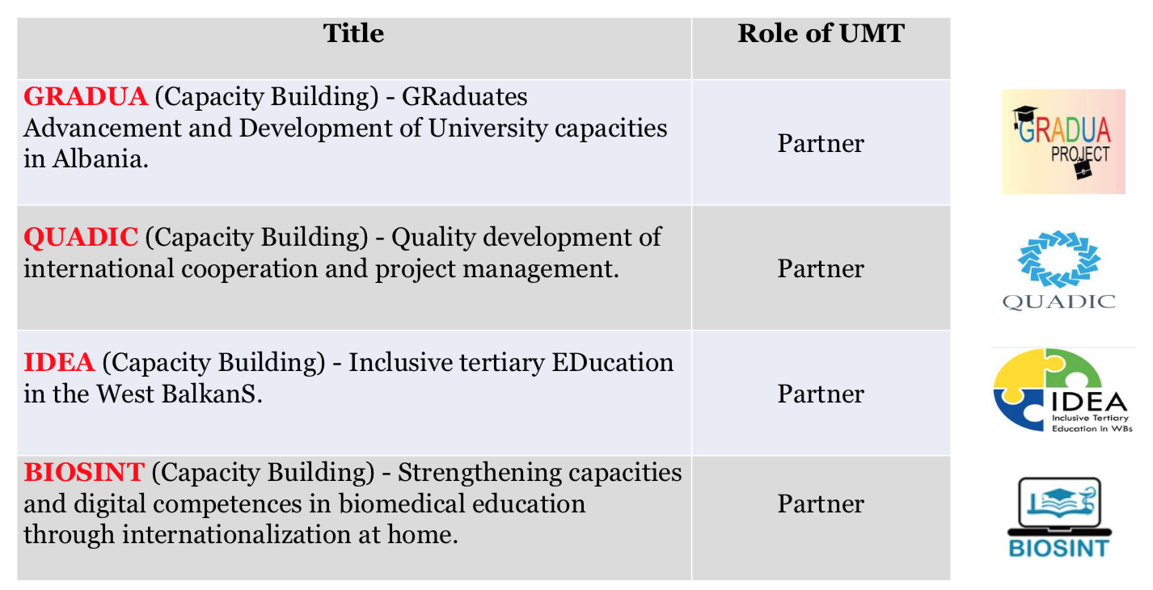

Broader objectives

The The UMTaims to become one of the most popular among Albanian universities worldwide by strengthening international orientation and cooperation. The main objective is to create a reliable and professional profile in relation to teaching, scientific research and international cooperation in the framework of research-development projects and cooperation for the building of mutual capacities.
In achieving this goal, the The UMTseeks to become the seat of cultural values and encounters not only through strengthening international cooperation, but also through the promotion of tolerance towards, respect and recognition of other cultures.
In order to fulfill the general objectives, the The UMT has set a number of long-term objectives, which focus on the following strategic aspects:
- Institutional partnership;
- International experience for students as well as academic and administrative staff,
- Internationalization of programs and curricula,
- International cooperation in the field of research, development and transfer of knowledge and technologies.

The direction of internationalization

Internationalization of higher education is a natural phenomenon and an encouraging possibility for development and creativity. Advancing internationalization by focusing on attracting more international students is the strategic focus. With internationalization, education not only develops students' critical thinking and logical reasoning, but they are also well prepared and equipped to engage with other people and businesses from other countries, wherever they are, and this it opens up more opportunities for them. The functioning of the the UMT in a globalized world without international relations is ineffective and in the medium and long term non-resultative. Although internationalization is a complex and multifaceted concept involving many elements, this process responds to local and global needs. The internationalization empowers students, staff and institutions with "lessons" from leading institutions abroad.

Strategic priorities

- Increasing the number of effective agreements with foreign institutions;
- Providing joint programs;
- Scientific research and joint projects

The strategic objectives aim at the involvement of the university in new activities and enterprises towards internationalization. They include:
- Promoting mobility for students and staff, both academic and administrative.
- Encouraging and supporting international cooperation in the field of research, development and transfer of knowledge and technologies.
- Strengthening the ties with the Albanian scientific diaspora.
- Increase international visibility of the university in the region and beyond.
- Reinforcement of administrative support services for project implementation and external relations.
- Internationalization of programs and curricula.
- Awareness of the cross-cultural component in relation to international partners.

Our aspiration

To increase our international reputation by providing high quality teaching, scientific research that responds to the international needs of a globalized world and partnerships with third parties for the purpose of knowledge transfer and services

SWOT analysis
Strong points
- Students of Network of Excellence
- High level of lecturers
- Large number of cooperation agreements with European Institutions
- Large number of inter-institutional agreements with partner Institutions in Erasmus Program countries
- A large number of lecturers engaged in international cooperation
- University of Medicine, Tirana is a member of several important International University Networks
- Large number of applications in projects with foreign financing in order to increase capacities

Weak points
- Lack of study programs in foreign languages
- Small number of incoming students from Erasmus+ program
- Non-cooperation with alumni members who live outside Albania
- Low interest of lecturers to participate in international projects

Opportunities
- Partnerships supporting university activities
- Interest in the expansion of academic programs
- Interest in offering joint/duplicate programs
- International development potential
- The special focus of the Ministry of Education and Sports on the internationalization of Universities
- Possibilities for opening joint/dual programs using European project funding

The Risks

- Lack of adequate funding
- Lack of incentives for pedagogues to participate in international activities
- Lack of knowledge and experience in the process of internationalization

The internationalization plan for the period 2020-2024

Objective | Activities | Support structures | Period
Internationalization through Scientific Research | - Collaboration with international prestigious universities.  - Publication of scientific articles in international magazines;  - Organizing joint activities (conferences, seminars, workshops) with foreign HEIs;  - Increasing participation in international projects.  - Absorption of scientific researchers and pedagogues with international experience.  - Applying to international scientific research projects. | - Main Units  - Basic units  - The sector of foreign relations  - Finance sector | 2020-2024
Internationalization through teaching | - Offering foreign language study programs  - Offering dual/joint study programs  - Opportunities for foreign students to be absorbed  - Increasing mobility of academic staff for teaching in foreign Universities  - Increasing the mobility of students for the development of a period of studies at foreign universities  - Increasing the number of visiting professors  - Better cooperation with the network of people decorated with the title Doctor Honoris Causa  - Increasing interinstitutional agreements with European Universities  - Incentives for the academic staff to participate in international activities  - Incentive for students to participate in mobility for the development of part of their studies  - Reorganization of curricula in order to fit the needs of the international market  - Building a network of student ambassadors of the UMT who have participated in international mobility  - Making the institution more attractive for foreign students  - Improving teaching skills for UMT lecturers through different trainings  - Request to the Ministry for the possibility of providing lectures in a hybrid way | - Academic Senate  - Board of Administration  - Main Units  - Basic units  - The sector of foreign relations  - - Finance sector | 2020-2024
Increasing the visibility of the Institution at international level | - Providing all the information of the UMT website in English and Italian  - Translation of all UMT documentation into English language | - The IT sector  - Communication Sector | 2020-2024
Improvement of conditions for foreign students who attend studies at UMT | - Providing specific guides for foreign students  - Facilitation of students throughout the application process, residence permit, accommodation, etc.  - The creation of a network of foreign students who have attended their studies for a period at UMT  - Offering scholarships to outstanding foreign students who choose UMT for their studies  - Creating specific instruments to measure student satisfaction | - Main Units  - Basic units  - The sector of foreign relations  - Finance sector  - Sports and alumni activities sector | 2020-2024
Establishing sustainable collaborations with foreign partners | - Building a specific guideline for the implementation of cooperation agreements  - Interruption of relations with Institutions which despite the agreements, nothing has been implemented | - Academic Senate  - Main Units  - Basic units  - The sector of foreign relations | 2020-2024
Adaptation of the curricula at the UMT with the curricula of the respective programs offered in the partner Higher Education Institutions in the European Union countries | - Organization of meetings for the purpose of curriculum adaptation  - Adaptation of the curricula in at least two programs for each Main Unit | - Academic Senate  - Main Units  - Basic Units  - Education Directorate | 2020-2024
The provision of a specific fund for internationalization, including the adaptation of curricula, the planning of joint study programs, etc. | - Specific fund for the internationalization | - Academic Senate  - Board of Administration  - Main Units  - Basic Units  - Foreign relations sector  - Education Directorate | 2020-2024
Integration and recognition of the subjects/courses/modules developed during mobility | - Recognition of the subjects/courses/modules developed outside Albania in the supplement | - Academic Senate  - Main Units  - Basic Units  - Education Directorate | 2020-2024

